Ed Ruth (1942-2021)

Southern California Swimming lost one of its stalwarts today, Edward (Ed) Ruth passed away in his sleep after a long battle with Parkinson’s. Ed was a native Southern Californian who graduated from UCLA then spent his working years at UCLA. While living in Thousand Oaks, he and his wife, Mendy, raised two swimmers, Valerie and Ed, Jr, who led them into the world of swimming volunteer extraordinaire.

Ed began his journey volunteering with his kids’ swim team (Conejo Swim Association) with summer league meets leading into USA Swimming competition. Ed would bring the timing equipment, set up the meet, run the timing equipment, etc. Then Ed was recruited to the world of officials where he quickly became a meet referee moving to the highest levels in USA Swimming as a Meet Referee at Nationals, an Olympic Team Trials’ official, and as Meet Referee for a 6,000+ World Masters Meet at Stanford. Along the way he also served as a Meet Director for 1989 Nationals at USC and for the 1991 Olympic Festival at USC.

Southern California Swimming presented Ed with the Phillips Volunteer Service Award in 1989 and created its Excellence in Officiating Award in his honor in 2012 with Ed as the first recipient. In 2013 Ed was recognized by USA Swimming as recipient of the Kenneth Pettigrew award for excellence and service in officiating. Ed was involved in SCS governance serving many years as Chair of the Board of Review plus four years as General Chair.

Everyone who had the privilege of working with Ed remembers him for his professionalism, his calm demeanor and his dry sense of humor. A friend, a mentor, he will be missed.
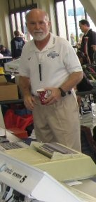
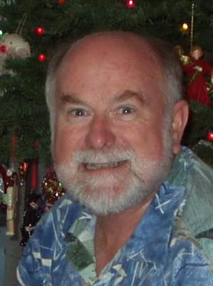

-30-

