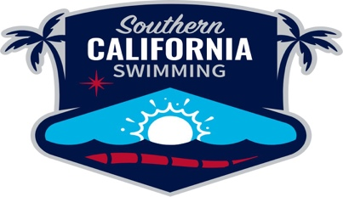 General Officials’ Meeting
Minutes, July 22, 2026
- Called to order at 7:35
- Minutes were approved from April 14, 2026 meeting
- Chair’s report:
- reviewed the information from the National Official’s Committee regarding rule changes.
- Hot August Nights: August 19, 26, and September 2 webinars
- Officials’ chairs summit in Denver, CO
- Recognized officials from Summer Sectionals; those receiving National Certifications
- No Report from the Athletes
- Geo Chair Reports
  - Ryan McCarty (Desert): Officials Clinic on September 12 in Las Vegas, Lisa Vitterlaine is the guest speaker
  - Hotels are being arranged for the clinic.
  - Application is available online in the SCS website
  - No reports from other Geo Chairs
- Old Business
  - Policies, procedures, and expectations for all positions of officiating
  - All officials must take online clinics for every position
  - Mentorship/training for apprentice positions must by the same
- New Business
  - Disciplinary action for meet referees regarding OTS
  - Applications for Winter Sectionals coming soon. Hosted by Brea Aquatics December 17-20
- Meeting adjourned: 8:46, Next meeting October 28 at 7:30 PM

