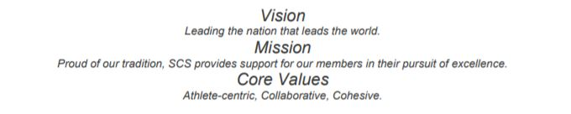

Southern California Swimming
Operational Risk Report
February 10, 2022
As of February 10, 2022,
- 140 teams registered
- 911 coaches and officials registered
  - 284 (almost 32%) have some part of their registration missing
    - Safety, CPR , BGC, APT are the most outstanding
Let’s be Members in good standing and protect your team!
Reminder: This is the letter that went to all members of USA swimming.
Starting January 1, 2022, the following individuals must be non-athlete members of USA Swimming:
- Adult employees of USA Swimming, Local Swimming Committees (LSCs) and member clubs;
- Adults serving on the board of directors of USA Swimming, LSCs and member clubs;
- Individuals in a position of oversight over the operations of a member club;
- Adults with an ownership interest in a member club;
- Referees, starters, administrative officials, chief judges, stroke and turn judges, ; and
- Other volunteers who interact directly and frequently with or have authority over athletes (as defined in the SafeSport Code for the Olympic and Paralympic Movement) as a regular part of their duties.
Please note that the following are new categories of individuals who are required to register as non-athlete members: adult employees of LSCs and member clubs, individuals in a position of oversight over the operations of a member club, and volunteers who interact directly and frequently with or who have authority over athletes as a regular part of their duties.
LSC staff such as business managers, webmasters, club registrars and membership coordinators, social media and communications managers will also be required to register as non-athlete members. This does not apply to volunteers such as timers, computer operators, etc. who only have limited contact with athletes during a meet.
For institutionally-owned clubs (e.g., clubs owned by a YMCA, LifeTime Fitness, college/university, JCC, etc.), this applies only to:
- The adult employees with direct oversight responsibilities over the club’s activities;
- The adult employees who have direct club-related responsibilities and whose responsibilities are not to all others using the facility (e.g., this would not apply to a lifeguard assigned to the aquatics facility whose duties are related to all in the aquatics facility as opposed to only the member club athletes); or
- The adult board members with direct governance/oversight responsibilities over the club’s activities.
These individuals will all be required to register as USA Swimming non-athlete “Other” members no later than January 1, 2022, and must complete Athlete Protection Training (APT) and a USA Swimming background screen.

