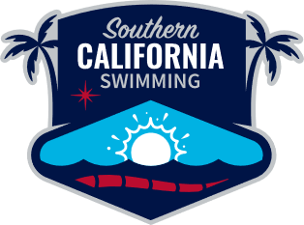
Agenda
Safe Sport-SCS
at 8:00 PM via Zoom
- Call to Order

- Review and approve the November 17, 2025 meeting minutes.

- Review and approve the January 27, 2026 agenda.

- Update on Action Items from November 17, 2025 Meeting

- Old Business

- New Business

- Announcements

- Next SCS Safe Sport meeting February 24, 2026

For more information or the link for the meeting, contact Sheri Stoddard @ sastoddard@pasadena.edu

SCS Mission:
Southern California Swimming embraces the diversity and inclusion of our membership across all skill levels, from water safety skills to all levels of competition from novice to elite, with a commitment to excellence that elevates dreams into reality, while supporting scholar-athletes and fostering a lifelong appreciation of the sport.

SCS Vision:
Southern California Swimming strives to develop its athletes’ skills in and out of the water, educate all its members on the lifelong lessons and benefits of swimming, instills character and discipline, and support the community as we welcome everyone into the sport.

