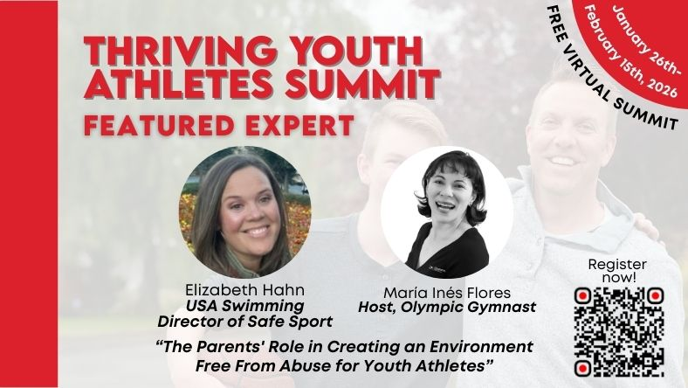

Hello all!
If you’re an athlete, coach, sports parent, or there’s an athlete in your life you support, you’re going to love this educational opportunity!
As a strong advocate for athlete and child wellbeing, I am proud to be a guest speaker at the "THRIVING YOUTH ATHLETES", a free virtual summit created by María Inés Flores - Olympic gymnast, sports parent, and founder of The Powerful Athlete.
María’s story is powerful.
At 17, she was so burned out that she competed at the Olympics… and retired the very next day. Her parents were great, but if they’d had a roadmap, her journey could have been different, and she probably wouldn’t have quit before getting the most out of the sport she loved. That’s why she created this summit, to support and guide today’s sports parents.

In this free summit, which I am excited to be a part of, you'll learn how to:
• Support athletes' big dreams and peak performance without burnout or excess stress
• Protect their mental health, confidence, and joy
• Make informed decisions in the athletes’ and their family’s long term benefit
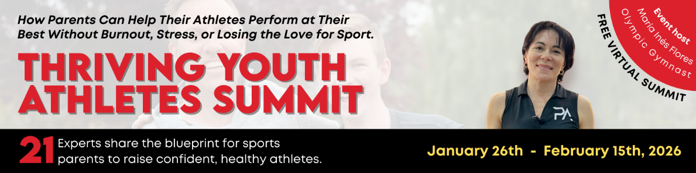

Why I’m passionate about this summit
It’s been my lifelong mission to protect children. The topic of my interview is “The Parents' Role in Creating an Environment Free From Abuse for Youth Athletes,” and I am happy to get the chance to deliver education and this important message.

I know that I’m not the only one who believes that sports can shape far more than athletic performance.

They help young people build resilience, discover their identity, learn how to handle pressure, and grow as confident, capable humans. If this resonates with you, register for this summit now, and share this invitation with someone who can benefit!
👉 Save your spot here: https://thrivingyouthathletes.com/SUMMIT?am_id=elizabeth7590
As always, thank you for all you do provide the safest and best experience for athletes.

See you at the summit,
Liz

Elizabeth Hahn
Director, Safe Sport

1 Olympic Plaza
Colorado Springs, CO 80909-5780
o: 719.866.3542
c: 719.237.2705

