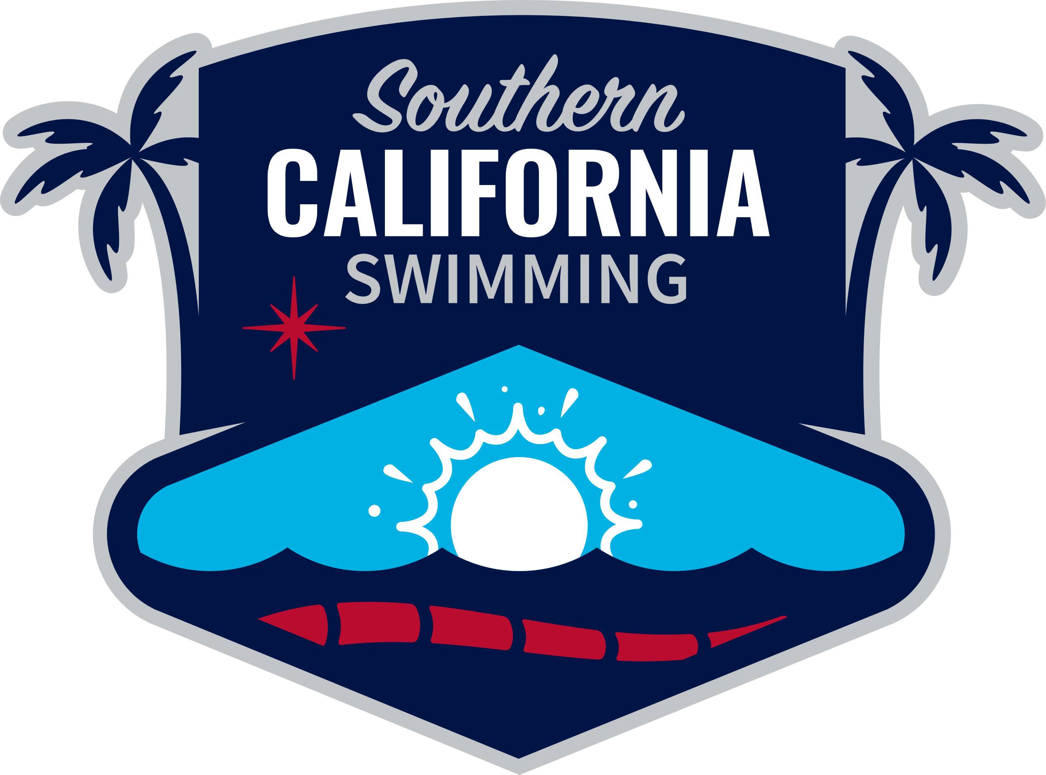

**Southern California Swimming V.3/2023**

**SWIMMING INFRACTION CODES**

**1 – BUTTERFLY**

**A Kick – Alternating motion (feet opposing)**

### B Kick – Breaststroke type (feet turned out propulsive part of kick)

**C Kick – Scissors type (not same horizontal plane)**

**D Arms – Underwater recovery**

**E Arms – Not simultaneous**

**F Turn, Finish – One hand touch or not separated (turn #)**

**G Turn, Finish – No hand touch - (turn #)**

**H Turn, Finish – Touch not simultaneous – (turn #)**

**J 15-meter (16.4 Yard) violation (start/ turn #)**

**O Shoulders - Not at/past vertical toward breast off the wall (turn #)**

**S Resubmerged prior to finish/turn #____**

**2 – BACKSTROKE**

**A Turn – Delay initiating pull once on breast**

**B Turn – Non-Continuous turn after pull**

**C Turn – more than one pull – (turn #)**

**D Not on Back – off wall – (turn #)**

**E Not on Back – into finish**

**F Not on Back – during swim**

# **G No Touch – (turn #)**

**H Start – Toes over lip of gutter after start**

**J 15-meter (16.4 Yard) violation (start/ turn #)**

**S Resubmerged during swim**

**6 – RELAYS**

**66 Early take off #2, 67 early takeoff #3, 68 early takeoff #4**

**61 Stroke infraction #1, 62 #2, 63 #3, 64 #4 - Code#**

**C Swimmer out of order – Swimmer #**

**D Not enough swimmers – Missing Swimmer #**

**E Fail to exit immediately – Swimmer #**

**F Re-enter before race over – Swimmer #**

**G Medley Relay – Strokes out of order**

**H Medley Relay – Repeat one of first three strokes**

**I Not on breast before any kick or stroke (Freestyle leg)**



**Southern California Swimming V.3/2023**

**SWIMMING INFRACTION CODES**

**3** – **BREASTSTROKE**

**A Kick – Alternating motion (feet opposing)**

**B Kick – Foot/Feet not turned out (propulsive part of kick)**

**C Kick – Scissors type**

**D Kick –Butterfly type kick**

**E Arms – Not simultaneous**

**F Turn, Finish – One hand touch or not separated (turn #)**

**G Turn, Finish – No hand touch – (turn #)**

**H Turn, Finish – Touch not simultaneous – (turn #)**

**I Hands – Not pushed forward together from breast**

**J Hands – beyond hipline after first pull**

**L Elbows – recovered over water**

**M Head Under– 2 or more strokes under water- (start/turn #)**

**N Stroke cycle out of order – other than 1 arm pull followed by one kick**

**O Shoulders - Not at/past vertical toward breast off the wall (turn #)**

**4 – FREESTYLE**

**G No Touch – (turn #)**

**J 15-meter (16.4 Yard) violation (start/ turn #)**

**S Resubmerged prior to finish/turn #____**

**5 – INDIVIDUAL MEDLEY**

**A Stroke infraction – Code #**

**B Strokes – Out of order**

**C Repeat one of first three strokes**

**I Not on breast before any kick or stroke (Freestyle leg)**

**7 – OTHER**

**A False Start B Declared False Start**

**C Delay of Meet D Fail to complete distance**

**E Entered water without permission – when??**

**F Interfered with another swimmer**

**G Walking on or springing from bottom**

**H Pulling on lane line I Finish race in another lane**

## J No show previous race K KT Tape violation

## S Swimsuit violation

## U Unsportsmanlike Conduct Z Other – Describe