Safe Sport Committee Meeting
October 7, 2025 - Rescheduled from September 23, 2025
- New SCS SSRP Recognized Team: Congratulations to Paseo Aquatics Swim Team
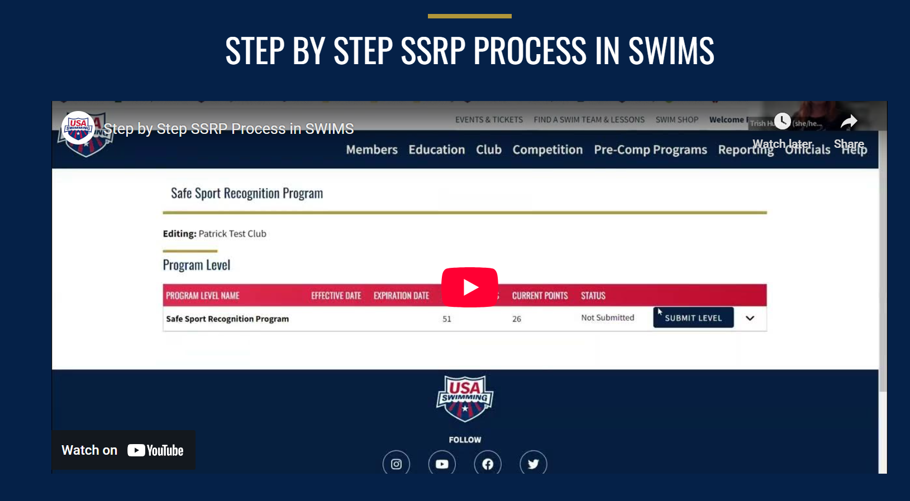
  - SCS has more teams than any other LSC in the nation
  - Some LSC’s require teams to be a SSRP Recognized Team in order to obtain a sanction for a meet.
  - There is some talk about this coming down the pipeline in the next 3 to 5 years
  - Consider getting your team recognized
  - Safe Sport Club Recognition Program - USA Swimming…STEP BY STEP HOW TO VIDEO .
- US Center for Safe Sport – information from presentation at 2025 USA Swimming Annual Summit in Denver Colorado
- US Safe Sport Items of Interest:
  - US Center for Safe Sport’s Codes
    - Physical Misconduct
      - The US Center for SafeSports Code states physical misconduct can include contact violations, non-contact violations, criminal conduct and exclusion
      - Examples of physical misconduct are:
        - Not giving appropriate water breaks during swim practice
        - Forcing athletes to train or compete when they are injured
        - Hitting or other forms of aggressive physical touch
        - Binding, strapping or using other forms of physical restraint
  - Emotional Misconduct
    - The US Center for SafeSports Code states emotional misconduct can include verbal acts, physical acts, acts that deny attention or support, criminal conduct and/or stalking.
    - Emotional misconduct is determined by the objective behavior/s and not simply by if harm was intended or results from behavior.
    - Examples
      - Repeated or excessive verbal assault without motivational purpose.
      - Repeated or severe physically aggressive behavior such as throwing sports equipment and water bottles.
      - Ignoring or isolating a person for an extended period of time.
      - Stalking, including cyber-stalking.
- Safe Sport for Parents
  - The Safe Sport for Parents page on USA Swimming’s website can be a valuable asset for swim parents. Feel free to explore the page and share to your membership
  - Link to read more
- What is SwimAssist?
  - USA Swimming's work to help athletes extends beyond free Safe Sport educational opportunities, valuable resources and response efforts for members.
  - Learn more about USA Swimming’s SwimAssist program is and who qualifies
  - Fund for survivors of abuse.
  - Link to read more
- October is Bullying Prevention Month
  - With October being Bullying Prevention Month, it is the perfect time to freshen up on FREE USA Swimming Safe Sport resources.
  - The Coaching Boys Into Men and Athletes As Leaders conversation cards allow coaches to conduct brief weekly (or monthly) conversations around scenarios.
  - Make sure your USA Swimming member club has an Action Plan to Address Bullying. If you need an example, USA Swimming Safe Sport provides a model policy here (also available in Spanish).
  - Sometimes reported issues are peer to peer. Does your club have a guide to address these reports? See USA Swimming's Safe Sport Guide: Peer to Peer for more insight on how to get started.
  - Posters are a great way to make sure all athletes are safe. Some examples USA Swimming Safe Sport provides include No Cameras, Locker Room guidelines and Reporting.
  - The 2021 Safe Sport Leadership Conference hosted amazing guest speakers who spoke on topics of Adverse Childhood Experiences, Cultivating Resiliency & Overcoming Obstacles, Why Trauma Informed Sport is Vital and Suicide Awareness and Prevention. Take a moment to review the webinars and slides, available on the Safe Sport archive webinars page
  - Link to Team Talk Website
- USA Swimming Safe Sport LSC Workshop
  - Sheri will be attending
  - USA Swimming LSC Safe Sport Chairs and Coordinators are invited to attend the USA Swimming LSC Safe Sport Workshop!
  - Saturday October 15th 3-6 PM
  - Who - LSC Safe Sport Chairs and Coordinators
- Reminder of CANRA requirement for CA
  - The State of California has enacted the Child Abuse and Neglect Reporting Act (CANRA). To assist our members residing in California, USA Swimming has provided resources on its website and has enacted new membership requirements for California-residing adult non-athlete members.
  - Next steps for California residents:
    - Access and review two new sample resources though the USA Swimming Safe Sport website.
      - Acknowledgement to Report Child Abuse Form
      - Suspected Child Abuse Report Form
      - Complete the Mandatory Reporting: Understanding Your Responsibility course on LEARN. It is suggested that you capture a screenshot of or save your completion certificate in PDF form, incase it is needed for future reference.
      - Send your certificate of completion for Mandatory Reporting: Understanding Your Responsibility to your Local Swimming Committee (LSC) Registration Chair.
  - Any California-residing non-athlete member who has not completed this training as of November 3, 2022 will be ineligible to participate with USA Swimming unless or until such time as the training is completed.
  - Link to learn more
- National Committee Applications Open Until October 14, 2022!
  - Committees are made up of volunteers from around the country and are essential in the governance of the organization. This year, we are looking to add new members to the Safe Sport National Committee.
  - Apply to the Safe Sport Committee, or any other National Committee, before Friday, October 14, 2022!
  - Link to learn more
- Anonymous Text Message Reporting - Available NOW
  - Any USA Swimming member can now report anonymously, if they wish, through text messaging at 888-270-SWIM (7946).
  - USA Swimming announced its alignment with RealResponse, an award-winning safe and secure feedback, monitoring and anonymous reporting platform.
  - "We are excited to provide this valuable new resource for our USA Swimming members," said Liz Hahn, USA Swimming's Program Director for Safe Sport.
  - All previous reporting mechanisms such as email, phone and the online reporting form, will continue to be available here.
  - Link to learn more
- Attend New Diversity, Equity and Inclusion Educational Webinars
  - Join USA Swimming's Diversity, Equity and Inclusion staff in USA Swimming's new webinar series!
  - The first webinar will be held on October 13, 2022 at 7 p.m. ET. It will focus on gaining a better understanding of how diversity, equity and inclusion can be utilized and enacted upon by all USA Swimming members at the club, Local Swimming Committee and National levels.
  - REGISTER HERE
- Reach Out to Your Zone Safe Sport Chair
  - Reach out to your USA Swimming Zone Safe Sport Chair to check in! Take the time to establish a relationship with your Zone Chair and see if they have any recommendations for you.
  - Remember, each Zone Chair can assist in the training of and dissemination of information to LSC Safe Sport Chairs/Coordinators. It is important to know who your Zone Chair is as they will help guide, support and share information with you throughout the year.
  - Our current USA Swimming Zone Safe Sport Chairs and their email addresses: Western Zone | April Walkley | iessafesport@gmail.com
- Reminder of Free Resources AVA
  - Safe Sport Club Recognition Tips Sheet
    - Has your club achieved Safe Sport Club Recognition? Use our Tips Sheet to help spread the word.
  - Coaching Boys Into Men and Athletes As Leaders Cards
    - These free, digital cards are available for clubs on USA Swimming's Safe Sport Team Talk page.
  - Parent Resource Guide
    - Although these were sent to every USA Swimming member household, save the digital copy for future reference!
  - Safe Sport Activity Books
    - You can either purchase books on Match-Up or download PDF versions for 5-11 year olds and 12-18 year olds.
- 2025 SSRP Trainings (link ava)
  - Safe Sport is committed to creating a healthy environment that is free from abuse for all members. As we continue with virtual learning opportunities throughout 2022, we will be increasing security measures to keep parents, athletes and coaches safe during trainings. All trainings will require individuals to register ahead of time.
  - In addition, we have enhanced our Safe Sport Trainings' security measures and will have the following in place:
    - Meetings will be locked
    - Athlete attendees will only have access to chat with hosts
    - Multiple USA Swimming Safe Sport staff will be on all trainings and will monitor participant video share
    - Frequent check-ins with attendees
    - Screen share and annotation capabilities will be disabled
    - Meetings will require registration and athlete training registrations will be cross-checked with USA Swimming member records
    - USA Swimming has enabled the At-Risk Meeting Notifier tool from Zoom. This tool searches the public internet for Zoom meeting information and checks the meeting's security settings. Zoom notifies USA Swimming if a meeting appears to be at high risk for being disrupted. This tool is enabled for all USA Swimming hosted Zoom meetings.
  - Safe Sport trainings are held monthly, please check the Safe Sport website to view upcoming training.
  - If you cannot attend these trainings, athletes and parents can independently complete trainings using the USA Swimming LEARN platform. Click the link below for more info on Safe Sport trainings.
  - Training Website link

