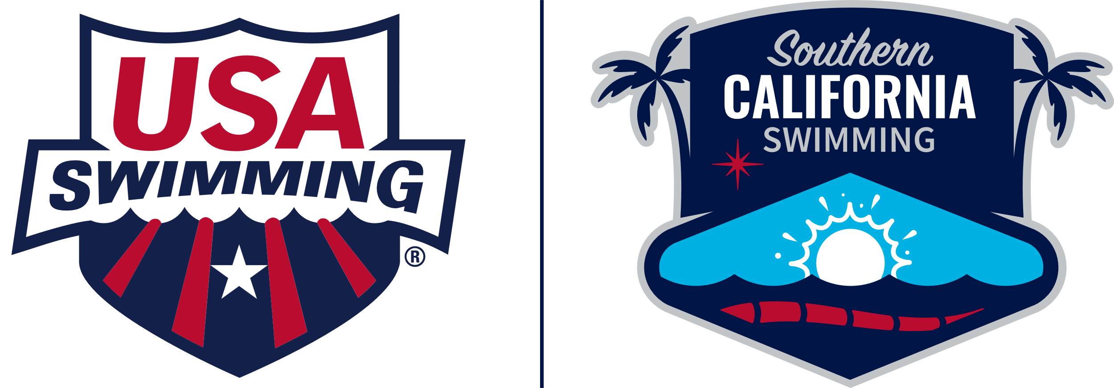**ATHLETE PROTECTION TRAINING FOR USA SWIMMING MEMBERS**

**Requirement**

* Annually
* Adult Athletes 18 and older
* All Non-Athlete Members - Coach, Official, Administrator, Other

**Course Progression**

* Athlete Protection Training: SafeSport Trained Core Course
* Refresher 1
* Refresher 2
* Refresher 3
* Do NOT take Safe Sport for Adult Athletes - this does count as the requirement for those 18 and older

**Course Access**

* SWIMS User Login
* Education
* Course Catalog
* All Courses - DO NOT select Safe Sport Courses as those are for the Safe Sport Recognition Program
* Select one of the courses listed above - based on your course progression, the next in the series is the only one shown

**Recommendations**

* Turn off all pop-up blockers (allow pop-ups in your browser)
* Use an updated version of Chrome or Firefox
* Complete everything on the screen including the ⌧ to close out the screen
* Take a screenshot of the full screen which includes date and time
* Those with a cognitive disability can request a [waiver](https://docs.google.com/viewer?url=https%3A%2F%2Fwww.usaswimming.org%2Fdocs%2Fdefault-source%2Fsafe-sportdocuments%2Fsafe-sport-basics%2Fathlete-protection-training-requirement-adult-athletes-with-cognitive-disabilities.pdf&urp=gmail_link)

**Troubleshooting**

* If you do not see one of the courses listed above, submit a Help Desk Ticket
* If you have completed the course but it has not updated to your member record
  + Select Help in the blue bar at the top right of your SWIMS User Dashboard
  + Click on Submit a Help Ticket and complete the form with as much detail as possible including your Name and Member ID and any screenshots

**Download or Print a Certificate**

* Go to safesporttrained.org
* Click on Login then forgot password
* Enter the email address used to take the training
* Click on the link in the email received from US Center for Safe Sport
* Enter a password
* Go to Login and enter username (included in the email) and your password
* Select the Menu icon at the top right in the blue bar
* Select Transcript
* Select the Download button for the course certificate you want to download.
* Click the Download icon on the top right to save a copy to your computer