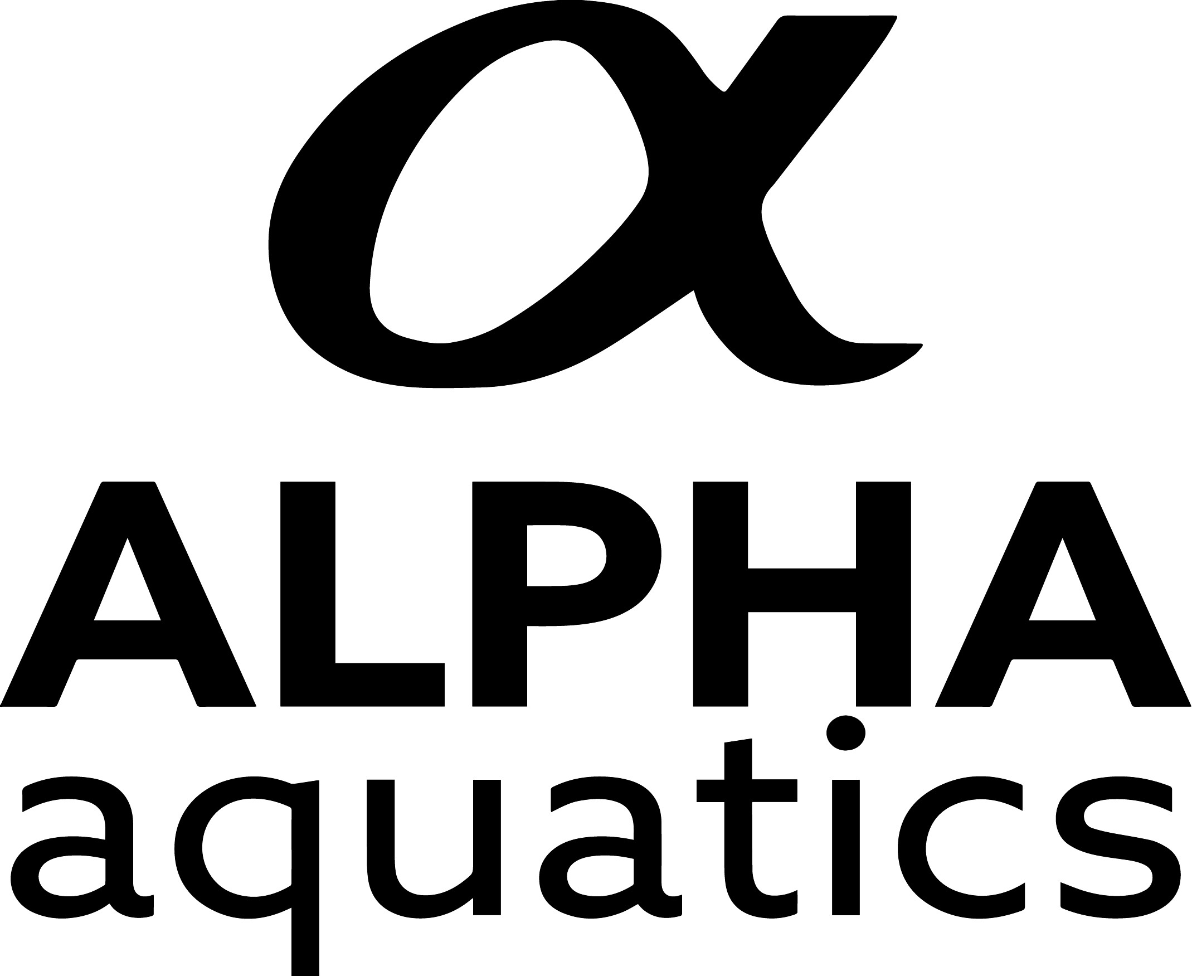

June 2025 Alpha Summer Classic
DATE OF MEET: JUNE 28 & 29, 2025
Sanctioned by: USA Swimming and SCS ENTRIES MUST BE RECEIVED BY 5:00 PM: WEDNESDAY, June 18, 2025
Sanction Number: XXXX
Sponsored by: Alpha Aquatics WARM UP TIME: 7:00 AM (Sat/Sun)
Pacific Committee MEET START TIME: 8:30 AM (Sat/Sun)

PM Session will begin no sooner than 11:00 AM or 45 minutes after the conclusion of the AM Session

POOL: | George Mannion Aquatic Center (GMAC) 2320 Crenshaw Ave. Torrance, CA 90503
COURSE: | George Mannon Aquatic Center is an outdoor 50-meter by 25-yard pool with 8 competition lanes and 6 warm-up lanes. Water depth at start end is 7.6 ft. and the same depth at the turn end. The competition course has been certified in accordance with104.2.2(C)
WARM UP RULES: | All lanes will be open for USA Swimming Member Coach supervised warm-up between 7:00 – 8:15 am. All swimmers must use a 3-point entry when entering the pool during warm-up except in designated dive lanes. Diving will be allowed in designated dive lanes only under the supervision of the coaches and marshals. Dive lanes will be assigned. Dive lanes will open 45 minutes before the start of the meet. The pool will close 15 minutes before the start of each session. If split-session warm-ups are necessary, coaches will be contacted by Meet Referee prior to meet.
MEET REFEREE: | Jetta Mate shall be in charge of the meet. Any questions regarding the conduct of the meet should be made directly to matejetta@yahoo.com.
RULES: | Current USA Swimming rules, including the Minor Athlete Abuse Prevention Policy 2.0 (MAAPP 2.0), govern this meet. Current SCS meet procedures will be enforced and take precedence over any errors or omissions on this form. This meet will limit entries to meet the “4 Hour” rule. This meet will follow all State, Local and Facility guidelines as it pertains to Covid-19. Swimmers must swim in their actual Age Group as determined by their age on the first day of the meet. Swimmers must be at least 5 years old on Start Date of the meet to enter. Timers are requested to be provided by each team. Events will be swum fast to slow. Swimmers may swim a maximum of 3 individual events per day. If more than 3 events per day are entered only the first 3 events of the day will be accepted. No exceptions or refunds All coaches and officials on deck must complete the CDC or NFHS Concussion course. course. All coaches and officials must have completed the CANRA mandatory reporting course.
SPECIAL NOTICE: | SWIMMERS MAY SWIM A MAXIMUM OF THREE (3) INDIVIDUAL EVENTS PER DAY. Alpha will limit entries to meet the “4 Hour” rule for each session. Each team is asked to provide timers. Relays will be swum, time permitting. ALL EVENTS WILL BE SWUM FASTEST TO SLOWEST.
RECORDING DEVICES & MEDIA NOTICE: | The use of audio-visual recording devices, including cell phones, is not permitted in locker rooms, changing areas or restrooms. Recording devices are not permitted behind the starting blocks during the starting sequence throughout the meet. This meet may be covered by the media, including photographs, video, web casting and other forms of obtaining images of athletes participating in the meet. Entry into the meet is acknowledgement and consent to this fact.
DRONES: | Operation of a drone, or any other flying apparatus, is prohibited over the venue (pools, athlete/coach areas, spectator areas are open ceiling locker rooms) anytime athletes, coaches, officials and/or spectators are present.
SWIMWEAR: | Swimwear must conform to USA Swimming Rule 102.8. Only swimsuits complying with FINA swimsuit specifications may be worn in any USA Swimming sanctioned or approved competition. “Tech” suits are not permitted at this meet for swimmers 12 & Under.
DECK CHANGES: | Deck Changes are prohibited.
RACING START CERTIFICATION: | Any swimmer entered in the meet unaccompanied by a USA Swimming Coach, must be certified by a USA Swimming member coach as being proficient in performing a racing start or must start each race from within the water. When unaccompanied by a member-coach, it is the responsibility of the swimmer or the swimmer’s legal guardian to ensure compliance with this requirement.
ELIGIBILITY: | OPEN TO ATHLETES WHO ARE 2025 USA Swimming REGISTERED. SCS athletes must be members of the Pacific Committee to be eligible for entry into this meet. Online registration in SWIMS 3.0 must be completed prior to the meet entry deadline. No late or deck registration will be accepted. In order to compete, all athletes 18 or older must complete the free online ATHLETE PROTECTION TRAINING prior to the start of the meet.
CHANGE OF AFFILIATION: | Club Transfers (unattach or attach) can only be completed online in SWIMS 3.0. At a meet, a swimmer may compete as Unattached but is responsible for completing the Club Transfer process online in SWIMS 3.0.
SUBMITTED TIMES: | Times submitted must be BEST RECORDED TIMES short course or long course from this or preceding swim season (NO WORK OUT TIMES). After entries close, meet admin will convert non-conforming times for seeding purposes only. Coaches and swimmers should be prepared to verify all submitted times. Discrepancy in the submitted times can lead to disciplinary action.
QUALIFYING TIMES: | If a swimmer does not have a recorded time but is otherwise qualified, he/she may enter the meet at minimum (see 2025 Swim Guide for exceptions). After entries close, non-conforming times will be converted by meet admin for seeding purposes only.
AWARDS: | No awards will be given at this meet.
ENTRY FEE: | $6.00 for each INDIVIDUAL EVENT, plus $15.00 SURCHARGE per swimmer must accompany each individual entry car. $10.00 per Deck Entered Relay. E-mail entry (entry.zip file) will be accepted ONLY when received with an attached Word or .pdf file including electronic signature of coach and will be dated as official at that time. (5 PM postmark would queue before a 10PM electronic). Full payment (single team check) for an e-mail entry must be postmarked within 48 hours of the e-mail entry. Failure to comply will be referred to the Board of Review. Entry updates (added events) will be processed when received by the processor by the entry deadline. Added events (entered swimmers may be submitted by hard copy (this includes e-mail) ONLY. New swimmers accepted SPACE AVAILABLE. DO NOT RESEND AN ENTRY FILE. A replacement file for the team will NOT be processed. Deletions will NOT be refunded. Coaches entering any qualified Outreach athletes in this meet, must provide their team outreach registration roster from SWIMS/USA Swimming to the Meet Admin, when sending their team entry report and file, listing the outreach athletes’ name. The Outreach athlete entry fee is a $15.00 flat fee.
DISABILITY: | Coaches entering swimmers with disabilities that require any reasonable accommodations or modifications, including the need for personal assistants, and/or registered service animals, must provide advance notice in writing (email), accompanying their meet entry file, to the meet referee by the entry deadline. Failure to provide advance notice may limit the host’s ability to accommodate all requests.
ENTRIES CLOSE: | ENTRIES MUST BE RECEIVED BY THE MEET PROCESSOR NO LATER THAN 5 PM, WEDNESDAY, June 18, 2025. IF THE MEET FILLS PRIOR TO THE DEADLINE, ENTRIES WILL BE REJECTED (LAST RECEIVED, FIRST REJECTED). To avoid any concern regarding receipt of entry card at the designated address, you are advised to enclose a stamped, self-addressed postcard or envelope for return when your entry is received.

NO CERTIFIED, REGISTERED OR SPECIAL DELIVERY MAIL WILL BE ACCEPTED.
PLEASE MAIL IN A BUSINESS SIZE ENVELOPE. DO NOT FOLD “White” ENTRY CARD---PLEASE.
MAKE CHECKS PAYABLE TO: Alpha Aquatics
EMAIL: meetprocessor@gmail.com
And MAIL TO: Alina De Armas
(Include Swimmer’s name and SCS Number) PO BOX 63 Simi Valley, CA 93062

For further meet Information email Theresa Le at theresale@gmail.com Receipt of entry will not be verified by phone.

June 2025 Alpha Summer Classic

DATE OF MEET: JUNE 28 & 29, 2025
Sanctioned by: USA Swimming and SCS ENTRIES RECEIVED BY 5:00 PM: WEDNESDAY, June 18, 2025
Sanction Number: S24 -
Sponsored by: Alpha Aquatics WARM UP TIME: 7:00 AM (Sat/Sun)
Pacific Committee MEET START TIME: 8:30 AM (Sat/Sun)
USA Swimming
Meet 360: Permanently suspended or ineligible individuals cannot be present on deck, coach, or perform any function at a meet requiring USA Swimming membership.
During registration, ensure all coaches, officials, trainers, massage therapists, LSC or host club staff, and medical professionals show proof of current USA Swimming membership (e.g., require them to show their Membership Card via the USA Swimming app) at registration. If such an individual cannot demonstrate proof of membership in good standing, deck access will not be granted.
Individuals permanently suspended or ineligible can be spectators at a meet and may be in the stands.
Violators shall be reported to the Meet Director or Meet Referee, who can then direct that individual to the spectator area. A subsequent report should also be made to USA Swimming.
A quality control system has been implemented to ensure that individuals who are ineligible for participation are unable to participate in this competition. Additionally, all adult members of USA Swimming who have not completed their Athlete Protection Training will not be able to participate in this competition.
Pursuant to USA Swimming Rules and Regulations and federal law, it is every member’s responsibility to immediately (i.e., within 24 hours) report any incident of child abuse, including physical or sexual abuse, to law enforcement and the U.S. Center for SafeSport may be made via telephone at 833-5US-SAFE (833-587-7233) or online at www.uscenterforsafesport.org/report-a-concern. Various state laws may also require reporting to law enforcement or to a designated child protection agency.
For information on how to report other alleged violations, including without limitation, the USA Swimming Code of Conduct, and the Minor Athlete Abuse Prevention policy, please visit www.usaswimming.org/report.
It is understood and agreed that USA Swimming shall be free from any liabilities or claims for damages arising by reason of injuries to anyone during the conduct of the event.

2025 Alpha Aquatics Summer Classic Meet Sponsored by Pacific Committee and Alpha Aquatics

